Nama : Rama Kisara

NIM : 18090117

Kelas : 5D

Laporan Praktikum 3

1. Source Code

view-form-matakuliah.php -> application\views\

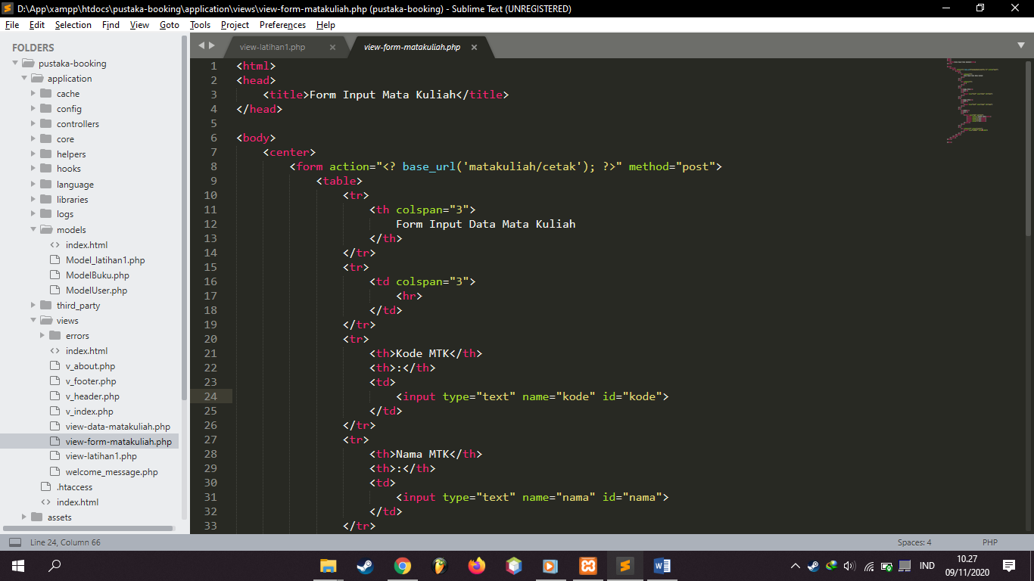

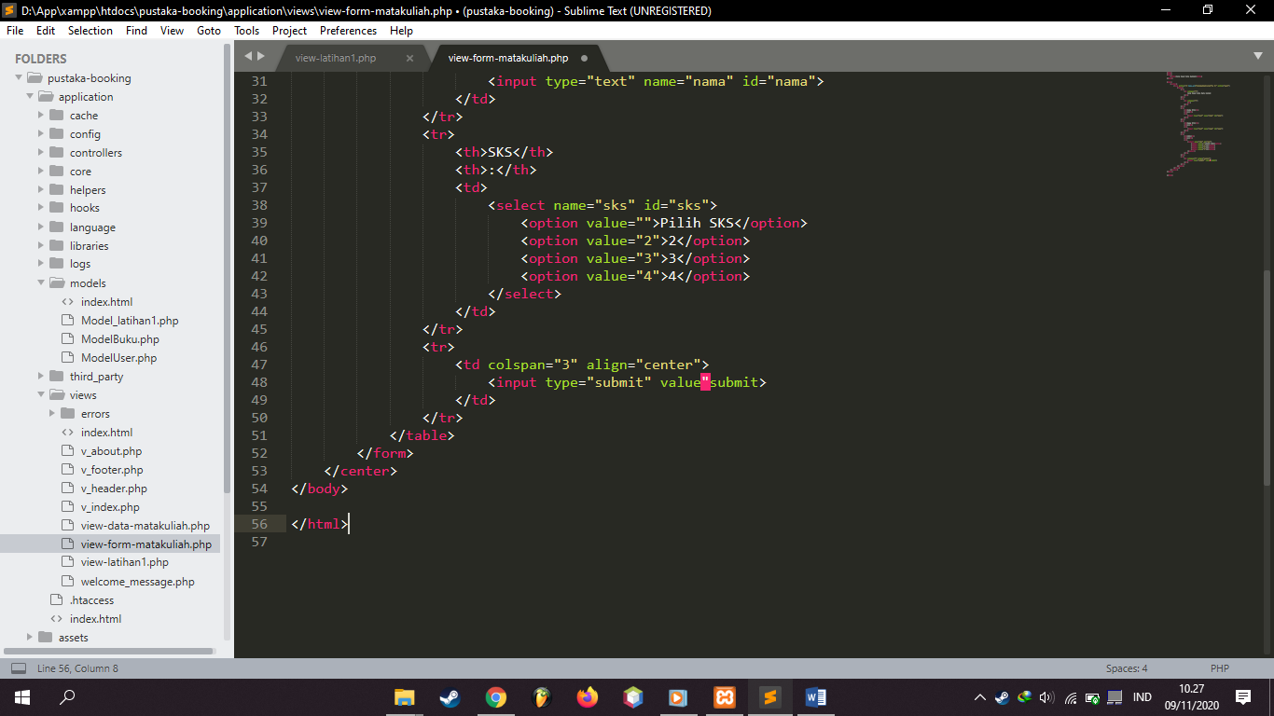

Matakuliah.php -> application\controllers\

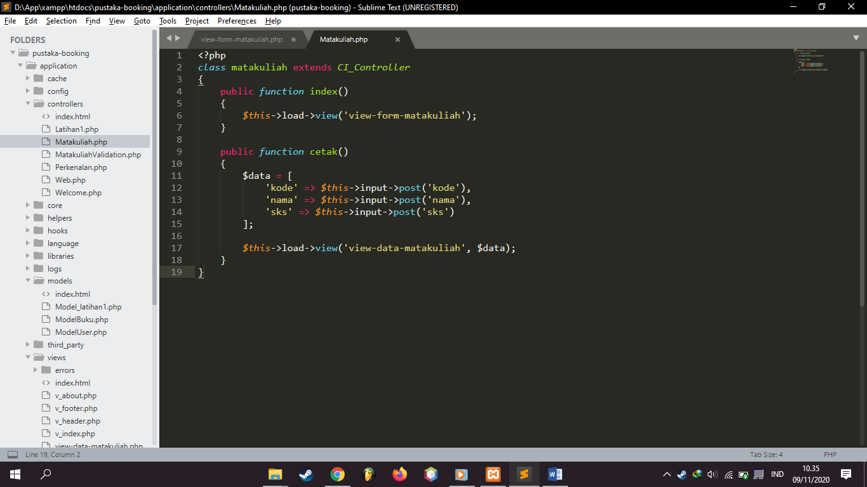

view-data-matakuliah.php -> application\views\



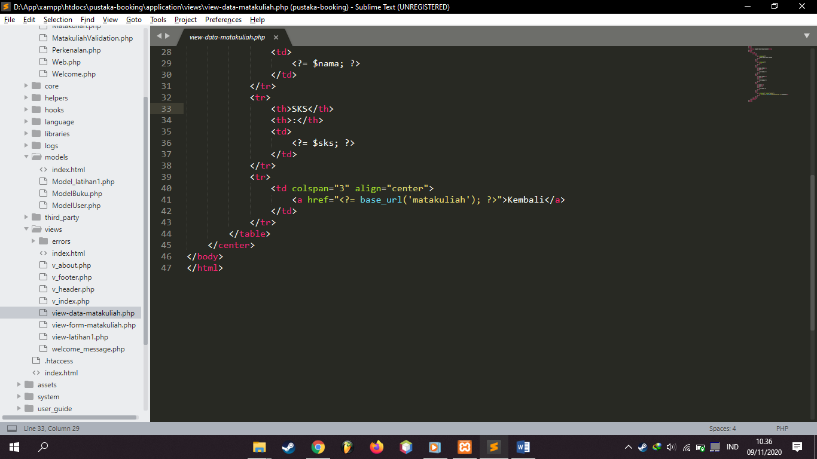

1. URL

<http://localhost/pustaka-booking/Matakuliah>

1. Capture Output Program

